**Friends and Family Test Results**

**December 2019**

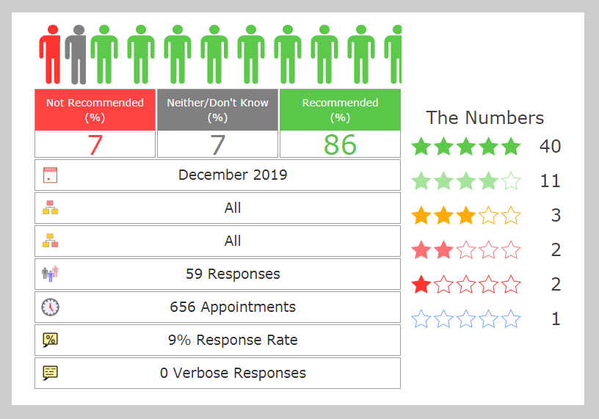

**We would like to thank our patients for this feedback.**

**We are always happy to hear your thoughts and suggestions.**